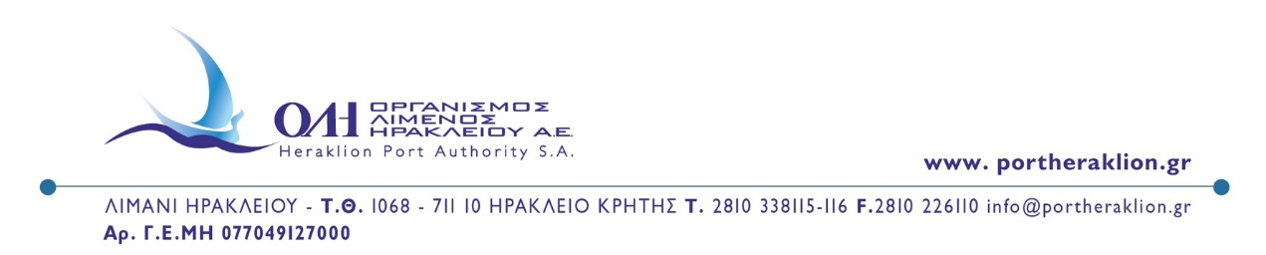
PRESS RELEASE
Heraklion, March 17th, 2026
Heraklion Port Authority at LET EXPO 2026 in Verona
CEO Minas Papadakis highlights the role of island ports in Europe’s sustainable maritime future
Heraklion Port Authority participated in LET EXPO 2026 – Logistics Eco Transport, held in Verona, Italy, from 10 to 13 March 2026. The exhibition is considered one of the leading European events dedicated to transport, logistics and sustainable maritime transport.
During the event, the CEO of Heraklion Port Authority, Mr Minas Papadakis, participated as a speaker in the panel discussion “Building a Sustainable Europe: Challenges and Opportunities”, where leading representatives of ports, shipping companies and logistics operators discussed the challenges and opportunities for strengthening sustainability, competitiveness and resilience within the European maritime sector.
In his intervention, Mr Papadakis highlighted the strategic importance of island ports within the European transport network, stressing that sustainability today is not only an environmental objective but also a key factor of competitiveness for modern ports. Particular emphasis was placed on investments in green infrastructure, port electrification, energy efficiency and the digitalisation of port operations as essential pillars for the development of a modern and sustainable port ecosystem.
Mr Papadakis also referred to the recent initiatives of the European Commission, which in March 2026 adopted the EU Ports Strategy and the Industrial Maritime Strategy, aiming to strengthen competitiveness, sustainability, security and resilience across the EU’s wider waterborne sector.
Heraklion Port Authority also participated in the exhibition as an exhibitor, holding meetings with representatives of ports, shipping companies, logistics operators and institutional stakeholders, promoting the Port of Heraklion and strengthening prospects for future cooperation within the European maritime community.
Mr Papadakis expressed his sincere appreciation to Mr Guido Grimaldi, President of ALIS (Associazione Logistica dell’Intermodalità Sostenibile), for the invitation and the excellent organisation of the exhibition, noting that the event has developed into a significant European platform for dialogue among ports, shipping companies, logistics operators and institutional stakeholders regarding the future of transport and sustainable maritime development in Europe.
The exhibition is organised by ALIS in cooperation with Veronafiere and brings together leading representatives of the international maritime and logistics community, highlighting the importance of cooperation between the public and private sectors in shaping a more sustainable and competitive European transport system.
FROM HERAKLION PORT AUTHORITY SA

