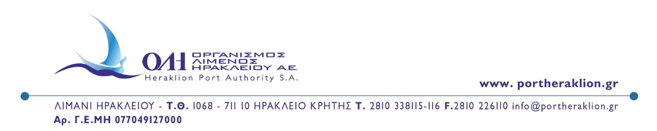
PRESS RELEASE
Heraklion, March 26th, 2026
Strengthening Environmental Management at the Port of Heraklion through a New Solid Ship Waste Management Contract
Heraklion Port Authority S.A. is moving forward with the enhancement of its environmental strategy through the signing of a new contract for the provision of solid ship waste management services, in cooperation with ANTIPOLLUTION.
The new contract constitutes a continuation and upgrade of the existing collaboration, further strengthening the port’s environmental performance through the implementation of modern waste management methods and best practices aligned with the most stringent European standards.
Through targeted improvements in equipment, procedures, and operational organization, the Port of Heraklion enhances its capacity to manage ship-generated waste safely and efficiently, actively contributing to the protection of the marine environment and the sustainable development of port activities.
This initiative forms part of a broader framework of environmental actions undertaken by the Authority, aiming to establish the Port of Heraklion as a port operating under high environmental standards in the Eastern Mediterranean.
The CEO of Heraklion Port Authority S.A., Mr. Minas Papadakis, stated: “The environmental upgrade of the port is a strategic priority for the Authority. Through the continuation and strengthening of our partnerships, we integrate modern practices and technologies that enhance our operational efficiency and actively contribute to the protection of the marine environment.”

FROM HERAKLION PORT AUTHORITY SA

